**Secure properties**

**==================================================================================**

**How to encrypt And decrypt secure property.yaml file**

**Step1:-** Download **secure properties tool** from google.

<URL:-> https://docs.mulesoft.com/mule-runtime/4.4/secure-configuration-properties

**Step2**:- place the Jar in the separate folder in your machine.



* place the decrypt yaml file in the same folder.

* now type CMD on the tp of the folder Path like as below

* Now run the command as below

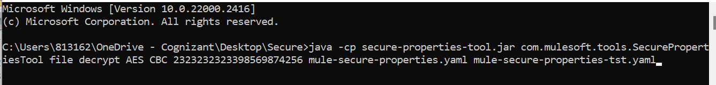

**Command to decrypt** :-

java -cp secure-properties-tool.jar com.mulesoft.tools.SecurePropertiesTool file decrypt AES CBC 2323232323398569874256 mule-secure-properties.yaml mule-secure-properties- decrypt.yaml

AES:- algorithm

2323232323398569874256:- decrypt key

mule-secure-properties.yaml :-file need to decrypt.

mule-secure-properties- decrypt.yaml:- on what file name we need to decrypt file.

* Once you Command was executed in the CMD output .YAML file same available on the same folder

You can Specify the other parameters as per your requirement.

**<operation>**

1. encrypt : used for encrypting value.
2. decrypt : used for decrypting value.

**Referral link** :- <https://apisero.com/secure-configuration-properties-secure-properties-jar/>

**Online Secure property generator:-** <https://secure-properties-api.us-e1.cloudhub.io/>

**Mule Studio plugin URL** :-

<http://anypoint-enterprise-security-update-site.s3.amazonaws.com/1.8.4>